Name: Khadija Parvaiz Butt

Roll Number: MCSF19M001

Subject: Mobile Computing

**Github Account:**

* First go to github website.
* Now Create a new account

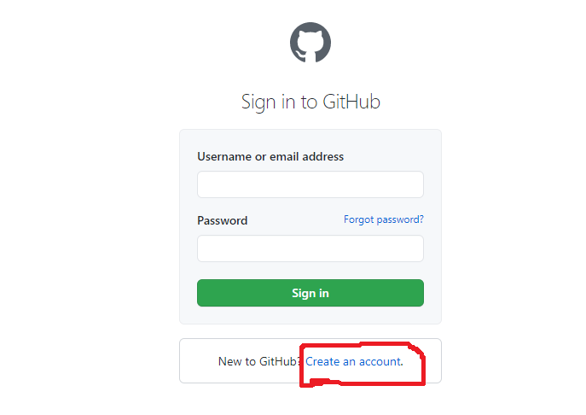

**Create Central Repository:**

Create the central Repository.

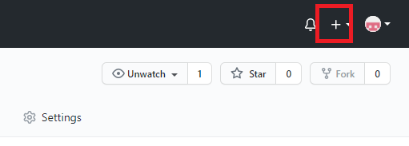

Give a Unique Name to your repository.

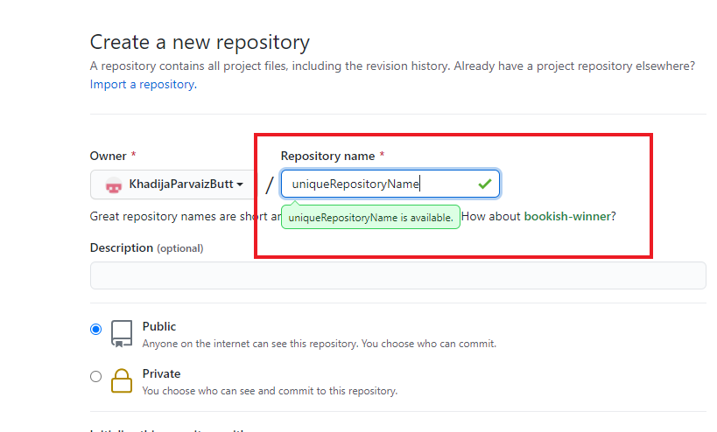

Then a URL will be given to your unique repository.

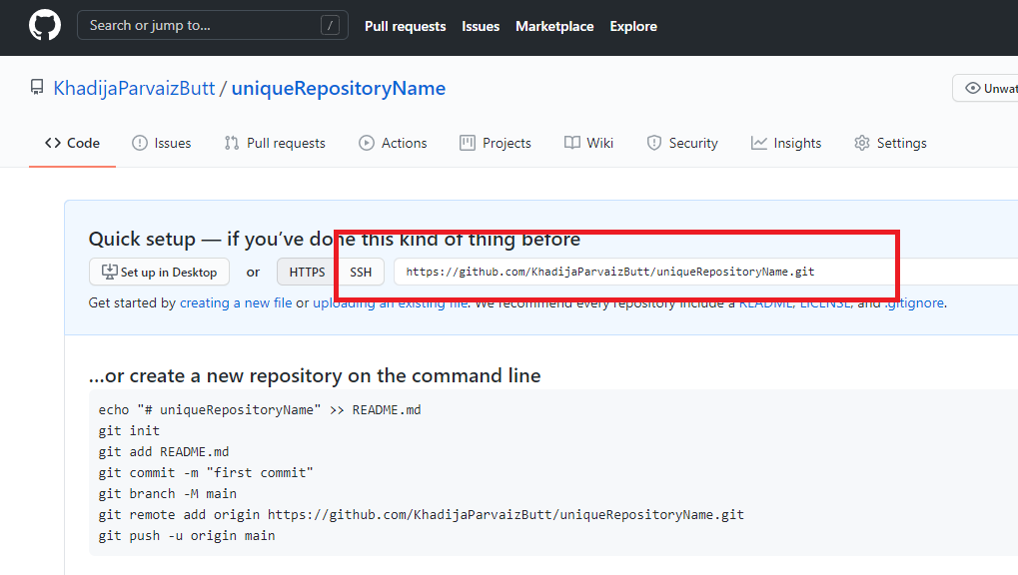

**Create Clone:**

git clone URLOfRepository

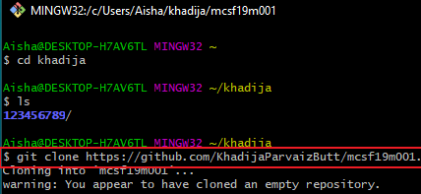

**Add File/Folder:**

* To add file write command: git add fileName.extension
* To add folder write: git add *



**Commit:**

* Commits are self explaintry messages.
* git commit -m “message”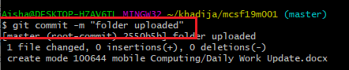

**Push:**

* After adding the folder/file in the local repository now we will push the local data to the central repository.
* git push

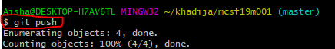

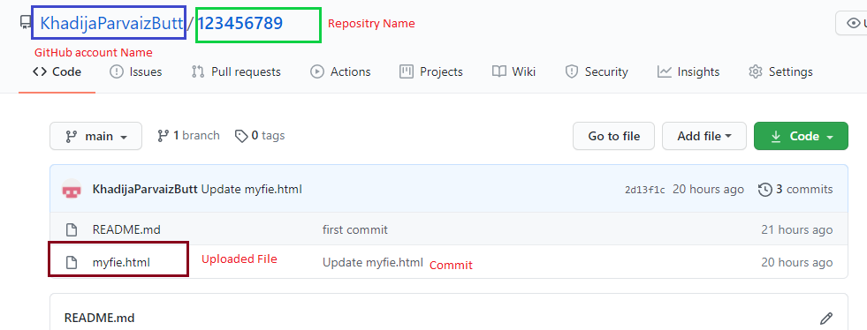

**Online Edit File:**

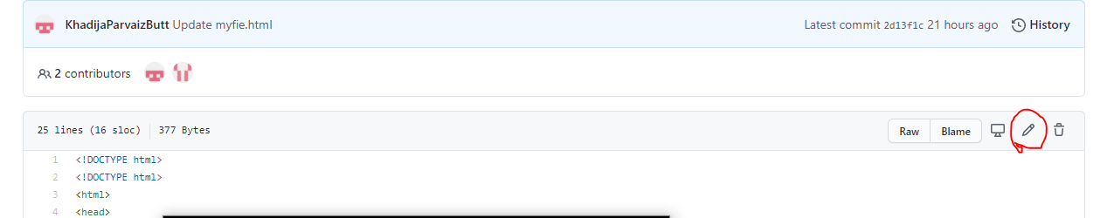

* Use the above to edit online.
* Make changes now commit.

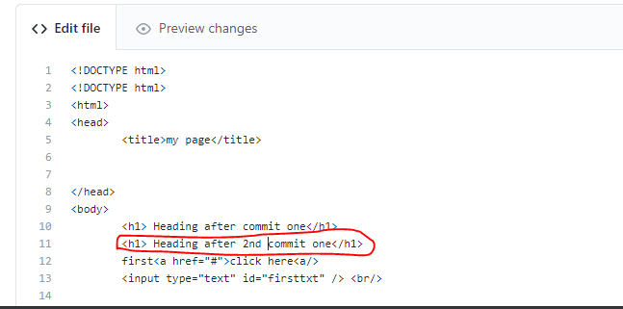

**Make changes in local repository:**

* git pull

